0C – Ampere’s Law

Topics: Ampere’s law, symmetries, magnetic field of a long wire.

Summary: Students first argue for why the magnetic field is entirely in the tangential direction for a straight current-carrying wire. They are then asked to recall Ampere’s law in integral form, and solve for the magnetic field around the wire.

Written by: Michael Dubson, Charles Baily and Steven Pollock.

Contact: Steven.Pollock@Colorado.EDU

Comments: Students should be able to complete these tasks within 15 minutes. This is meant to be a short review activity, so the time-estimate is based on students already having a reasonable familiarity with using Ampere’s law to solve for a field. The previous activity on Gauss’ law was more explicit about making symmetry arguments on the first page, and many students may still do this after having completed that prior activity. Others were more comfortable thinking in terms of there being no magnetic charges, and the curl (or closed line-integral) of the B-field being zero where there is no current (enclosed). There is also no scaffolding in this activity regarding the choice of an Amperian loop, or finding the current enclosed by that loop – instructors should be aware that understanding the symmetry arguments in applying Gauss’ law doesn’t necessarily translate to the context of Ampere’s law, but we anticipate students having less difficulty after considering the symmetry questions from the Gauss’ law activity. A more sophisticated question involving symmetry comes as an optional “challenge” question at the end, which asks if Ampere’s law can be used to find the B-field at the center of a circular loop of current. This question was also used as a review concept test in our classes, and in both cases inspired a great deal of discussion/questions among students. Many of them felt that the field from a differential element of current could be found using Ampere’s law, then integrate the contributions from around the loop to find the total field. Just as with Gauss’ law, this again shows that students may have the rote application of Ampere’s law down, without necessarily understanding the role of symmetry in its correct application.
A. We will use Ampere’s law in integral form to determine the magnetic field around a long straight wire, carrying a current . Usually, we begin by assuming that the magnetic field around the current-carrying wire is entirely in the tangential direction.
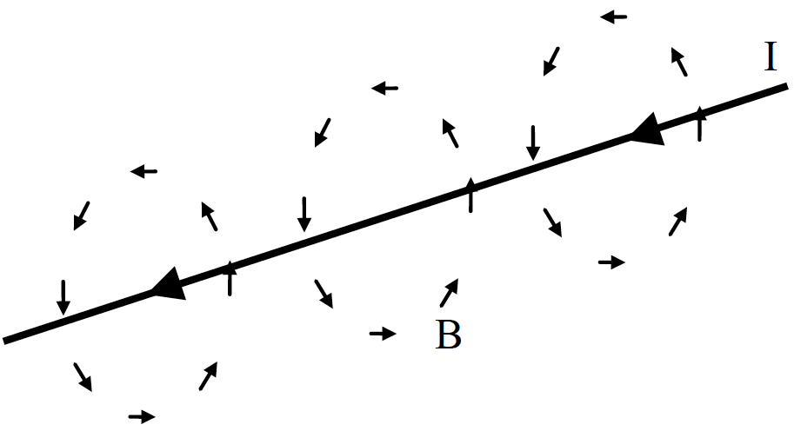

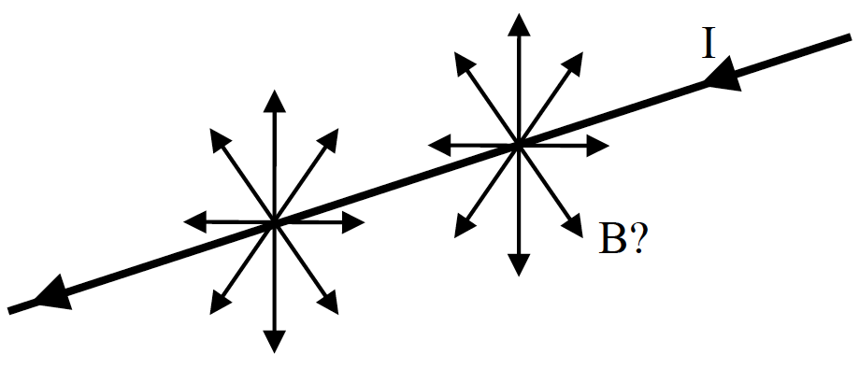
Give a brief argument for why the magnetic field should not have a radial component (outwards from the wire).

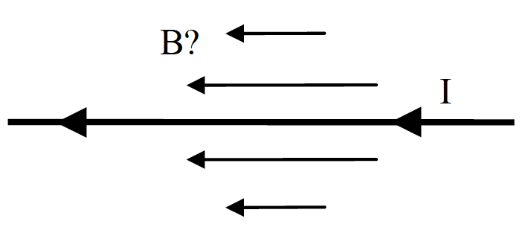
Give a brief argument for why the magnetic field should not have a longitudinal component (parallel with the wire).

B. Here is Ampere’s law in differential form:

Now, write down Ampere’s law in integral form.

C. Use Ampere’s law in integral form to solve for the magnetic field around the wire. Briefly define any symbols you use.

Challenge Question: (for the really fast teams)

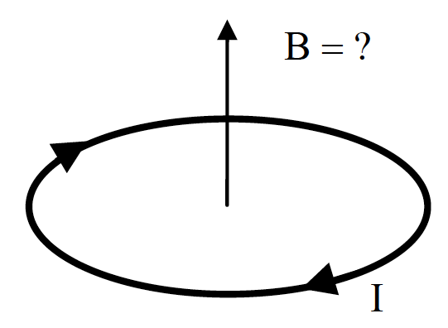
Can we use Ampere’s Law to compute the B-field at the center of a circular current-carrying loop of wire? Why or why not? If not, then how could you calculate the field there?

